Thank you for the thoughtful comments on our manuscript. The reviewers clarified the novelty and importance of our paper – there is an extreme dearth of knowledge on behavioral responses to dynamic temperature-oxygen trade-offs in freshwater ecosystems. Both reviewers appreciated our analytical framework that predicted DVM based on first principles and then corroborated our predictions in the field. We believe we can directly address the concerns raised by the reviewers and we request to resubmit the revised manuscript for further consideration.
The reviewers identified 4 key shortcomings:
Correlation between temperature and DO limits inference:
While temperature and DO co-vary, their relationship is not static. As shown in Figure 3 and Supplemental Table 2, the slope of the temperature–DO trade-off differs substantially between day and night and across alcoves, creating windows where fish encounter varying environmental constraints. To explore how fish respond to these conditions, we used a predictive modeling approach that focuses on model outputs rather than coefficient interpretation, a strategy recommended when variables are correlated (Dormann et al., 2013). To further examine temperature effects, we held DO constant in our visualizations, allowing us to isolate thermal responses within a plausible range of DO conditions. While we recognize that this approach simplifies natural complexity, it offers useful insight into how temperature may influence depth selection. That said, if the reviewers feel this modeling approach detracts from the manuscript’s clarity or interpretability, we would be happy to remove it or include it in the supplemental material.
Could depth selection be from maintaining temperatures close to thermal optima of 14C:
As we show in our model, if fish were selecting solely for thermal optimization and reduced metabolic rate, we would expect deeper occupancy in colder, low-DO zones. Instead, fish remain near the upper edge of hypoxic layers, suggesting they are balancing thermal preferences with oxygen constraints. While other factors may contribute, our data support DVM as a thermoregulatory strategy constrained by oxygen availability rather than driven by foraging, predation, or temperature alone. It is unlikely that fish are exhibiting DVM to track an optimal temperature of 14°C; previous work on westslope cutthroat and bull trout has shown that these species often occupy habitats well below their presumed thermal optima, particularly in cold-water refuge systems (Isaak et al., 2015). Reviewer 2 suggests that temperature selection could reflect functions other than metabolic optimization, such as immune function or reproductive maturation. While we cannot fully rule out these possibilities, several lines of evidence make them unlikely. First, in Barrett et al. (2023), we showed that fish across different alcoves consistently selected for temperatures in the thermocline, which ranged from 14-16°C. If fish were tracking a fixed thermal optimum (e.g., 14°C), we would expect more consistent temperature selection across sites, which we did not observe. Our focal species is a spring-spawning salmonid, and the study was conducted outside of the reproductive period. Additionally, temperatures above 12°C are generally considered suboptimal or harmful for embryo development in spring-spawning, making it unlikely that warmer temperatures would be selected to support reproductive maturation. Together, these points suggest that the observed behavior reflects constraint-driven thermoregulation, rather than pursuit of a fixed physiological optimum for other life history processes.
Other factors beyond the temperature–oxygen trade-off may explain DVM behavior (e.g., foraging, predation, or physiological processes like immune function).
No ecological study can definitively rule out all alternative hypotheses. However, our existing data strongly support the interpretation that DVM is driven by dynamic trade-offs between temperature and dissolved oxygen (DO), rather than foraging or predator avoidance. We have already published a paper (Barret et al. 2023) establishing that the daytime depth selections of our focal fish reflect a temperature-oxygen trade-off. Within and across sites, cutthroat trout held at the depth of the thermocline. The depth and temperature of the thermocline varied across space – if predation risk or temperature alone was driving behavior, fish would not strongly select for the thermocline depth, which is the rare location (i.e. a small fraction of the water column) where intermediate combinations of T and DO occur.

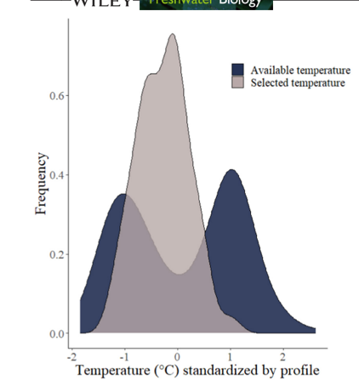
In a separate manuscript in preparation, we show that fish feed minimally in cold-water alcoves. Their diets contain ~ ¼ the total energy content of fish that do not use refuge habitats, and they exhibit ~3-fold lower activity costs. This paper shows that our focal trout opportunistically consume prey that traverse the water column, (i.e., water boatman and chironomid pupa) but consume few prey. None of their prey are known to exhibit DVM and their primary predator (Osprey) are diurnal, so there is no reasonable explanation for their scant foraging to drive a nocturnal ascent.
At times DO is uniformly low across the water column:
We agree that in some cases, particularly at night in Blue Ruin, DO was uniformly low. This is clearly noted in the results (lines 325–327) However, our data also show that during the day, DO conditions improve at depth, enabling fish to shift downward and gain thermal benefit. The observed DVM (Figures 4b–c) and selection shifts (Figure 6) are consistent with this pattern.
We appreciate the thoughtful feedback provided by the reviewers and the Associate Editor - the comments have clarified key areas for improvement and we would be happy to revise the manuscript to address the concerns raised. We would appreciate the chance to submit a revised version for your consideration if we have adequately addressed these key concerns.

